Assignment

- What is Data Modeling in Power BI? With example (Not the data We used in the class)
Data Modeling in Power BI refers to the process of organizing and structuring data from several tables into a model that enables effective analysis, visualization, and reporting .

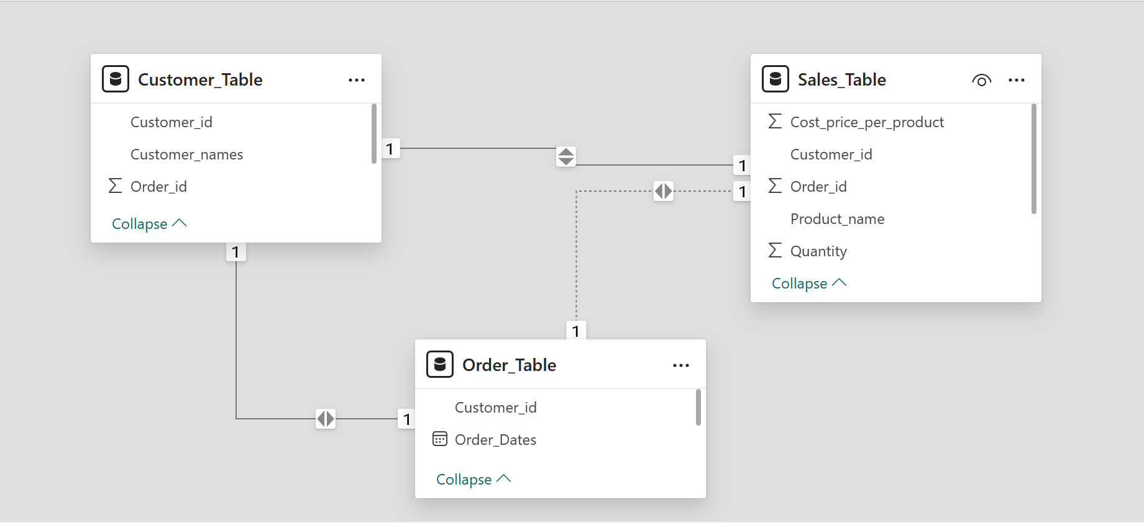

- Explain the difference between a calculated column and a measure.Give example
Calculated column | Measure
Calculated column is a row by row calculation applied inside the table that affects the table and it is best used for filtering and creating relationships. | Measure are calculations applied outside the table that can only be seen by using visualization and it is best used for aggregations(e.g. sums, averages)
Example of Calculated column

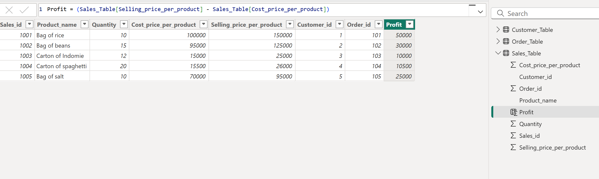

Example of Measure

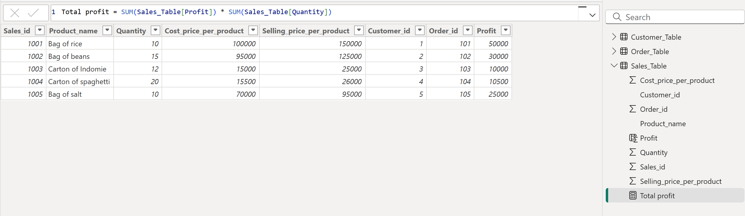

- What is DAX in Power BI? Give an example.
Dax Analysis Expression(DAX) is a programming language used for creating formulas and expressions that are used for performing calculations and manipulating large data sets.

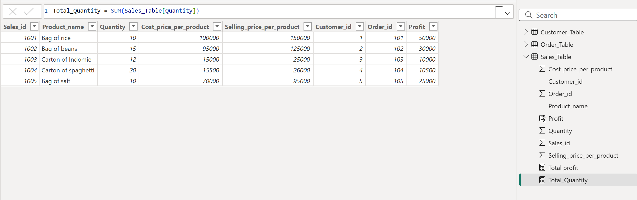

4.Write a DAX formula to calculate Total Sales = Quantity × Unit Price.
Total Sales = SUMX(Sales_Table , Sales[Quantity] * Sales[Unit Price])

5.What are Time Intelligence Functions in DAX? Give two examples.
Time Intelligence Functions in DAX are functions that helps to perform calculations based on dates (e.g., YTD, MTD etc.).
Examples are;
Monthly Purchase = CALCULATE(SUMX(Sales_Table,Sales_Table[Quantity]*Sales_Table[Purchase_Price]),MONTH(‘Order_Table’[Order_Date]))

Sales YTD = TOTALYTD(SUM(Sales_Table[Sales_Price]),’Order_Table’[Order_Date])

6.How do you create relationships between multiple tables in Power BI?
- Go to Model View.
- Move a column from one table to the corresponding column in another table (for example, CustomerID).
- There will be a relationship line.

7.How do you use Drillthrough and Drilldown in Power BI reports?
Drillthrough | Drilldown
It is used to navigate to a detailed report page | It is used to explore deeper levels in the same visual

8.What is the difference between SUM() and SUMX() in DAX?
SUM() | SUMX()
It is used to add up values from a single column e.g. SUM(Sales[Amount]) | It is used to evaluate an expression row by row and then sum e.g. SUMX(Sales_Table , Sales[Quantity] * Sales[Unit Price])

9.What is the use of Power Query Editor in Power BI?
Power Query Editor is used for data preparation and transformation before modeling.
10.What is the purpose of the RELATED() function in DAX?
The RELATED() function brings a value from a related table into the current row context.

